CSE 204 – Computer Network

Lab Test

Student name
Student ID

Objective
- Implementing VLAN and VLAN Trunking
- Implementing DHCP
- Implementing Static Routing and Dynamic Routing
- Implementing Static NAT and PAT

Assignment list
II.1. Implementing VLAN and VLAN Trunking
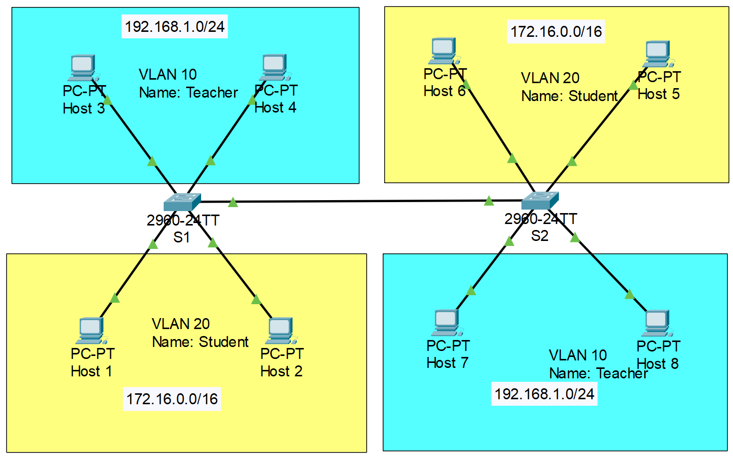
- Note: VLAN 10: port 5, 6. VLAN 20: port 8, 9. Trunk: port 1
- Configure VLAN as shown in the figure above. Then, implement VLAN Trunking on 2 Switches, so that 2 PCs in the same VLAN, but different Switch can ping to each other.
II.2. Implementing DHCP
- Configure DHCP in each router based on the given information in the figure below.
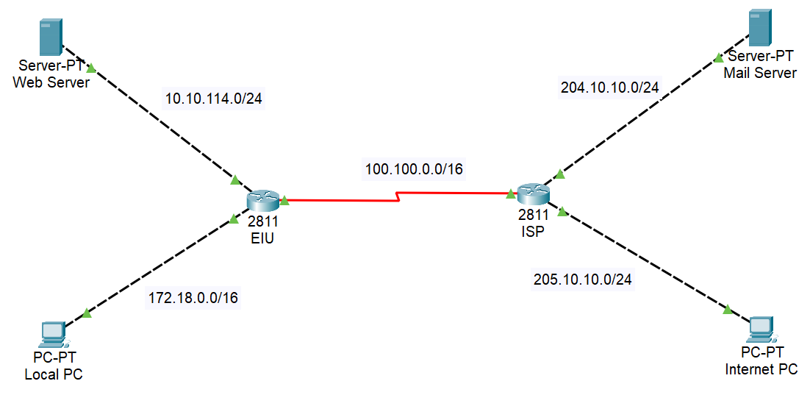

Note: Before proceeding to the tasks below, please CLONE the model after configuring DHCP

II.3. Implementing Static Routing and Dynamic Routing
Note: Use the clone model to configure Static Routing and Dynamic Routing separately.
- Use the model in Task II.2 to configure Static Routing
- Use the model in Task II.2 to configure Dynamic Routing
II.4. Implementing Static NAT and PAT
Note: Use the clone model to configure Static NAT and PAT.
- Assume that Router EIU will use the public IP address 200.10.0.0/24 for Static NAT. Configuring Static NAT at Router EIU to translate private IP address of Web Server to public IP address.
- Configuring PAT at Router EIU to translate private IP address of Web Server to public IP address.

